**Week 1**

**Research**

Explain Guided/Unguided media give examples.

* Guided media is where data signals (either digital or analogue) pass through a physical medium between devices. Examples of this would be a copper coaxial cable or a fibre optic cable.
* Unguided media is the transmission of data signals through the air. This is often referred to as wireless transmission. Examples of this would be radio transmission or satellite transmission.

Research the pin-out of a Crossover and a straight through network cable (give diagrams).

* A straight through is exactly how it sounds. The wire colours on both connectors have to be in the same pins as each other. I.e. if the white/orange wire is in pin 1 on one of the connectors the white/orange wire at the other end of the cable must go in to pin 1 on the other connector. This is the same for all the other wires.

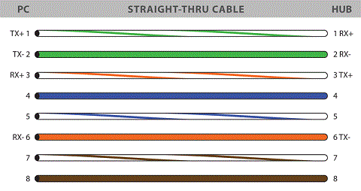 (http://www.fiber-optic-cables-plus.com, n.d.)

* A crossover is different in that;
  + Connector 1 – pin 1 must link to connector 2 – pin 3
  + Connector 1 – pin 2 must link to connector 2 – pin 6
  + Connector 1 – pin 3 must link to connector 2 – pin 1
  + Connector 1 – pin 6 must link to connector 2 – pin 2
  + The rest are the same as a straight through.

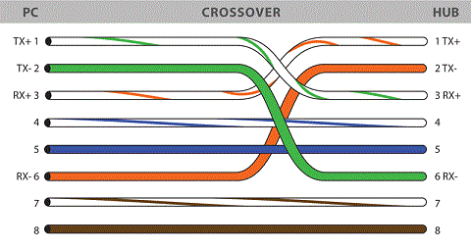 (http://www.fiber-optic-cables-plus.com, n.d.)

**Tutorial 1**

Write down a simple definition which describes the meaning of the term “Computer Network”.

* A computer network is 2 or more computers which are connected together autonomously.

Give 3 advantages for networking computers.

* By sharing devices on a network (printer) you can save resources by not having to buy these devices individually.
* There is the added benefit of reliability. Where you are able to backup files in multiple places, which protects again the loss of data.
* It makes transferring data between computers easier.

What was “Arpanet”?

* The Advanced Research Projects Agency Network (ARPANET) was a network of 4 university computers.

What are 3 classifications of computer networks related to size?

* LAN (Local Area Network), MAN (Metropolitan Area Network) and WAN (Wide Area Network)

Define the term “Bandwidth” as related to computer networks.

* Bandwidth relates to the amount of data which can be transferred from one place to another in a set amount of time, usually 1 second.

What is the function of a modem in computer networks?

* A modem converts data which is in a digital form into an analogue form and then transmits the data.

What is a NIC as used in computer networks?

* A NIC is a Network Interface Card which is an expansion card that allows a computer to connect to a network.

What is a MAC address and why is this needed for devices on a network?

* A MAC address (Media Access Control address) is the address of a device so it can be identified on a network.

Describe the function of a 4 port (ports 1/2/3/4) hub which has a signal arriving at port 1.

* The function of the hub which has a signal arriving at port 1 is to send the signal on to all the other ports, regardless of whether it is the intended destination or not.

In relation to computer network devices, what is the difference between a hub and a switch?

* The difference between a Hub and a Switch is that the Switch does the same job but more efficiently by being able to inspect the data packets and then forward it on to the correct destination. This helps to conserve network bandwidth and gives better performance.

What is the main function of a router in computer networks?

* A routers main function is to link networks by forwarding data packets between them.

What is the function of a firewall in a computer network?

* The function of a firewall is to monitor and control network traffic based predetermined settings.

Describe the meaning of the term “Access Point” in relation to computer networking.

* An access point is usually connected to a wired network, it allows wireless devices to connect to the wired network.

What are the 3 basic communication media used in computer networks?

* Coaxial Cables / Fibre Optics / WIRELESS.

**Week 2**

**Research**

Topologies

* The name given to differentiate between the different arrangement of nodes and connecting lines within a network is a Topology. Some examples of these are Bus, Star, Token Ring, Mesh and Tree.

Simplex

* Simplex is the name given to any kind of broadcasted communication in which information can travel in one direction only. An example of this would be a television.

Half-Duplex

* A half-duplex system allows for users to communicate both ways, but it only allows for communication one way at a time. An example of half-duplex would be walkie-talkies.

Full Duplex

* A full duplex systems allows for users to communicate both ways and at the same time. An example of this would be a mobile phone.

TCP/UDP/VOIP

* TCP - Transmission Control Protocol
* UDP - User Datagram Protocol
* VOIP - Voice over IP

**Tutorial**

For successful communication, how many listeners and talkers are allowed?

* You need one talker and one listener for successful communication.

How does the Ethernet standard cope with multiple talkers?

* By making use of protocols such as Carrier Sense Multiple Access (CSMA).

Explain the operation of the 3 modes of communication?

* The 3 modes of communication are Simplex Transmission, Half-Duplex Transmission and Full Duplex Transmission.
  + Simplex is the name given to any kind of broadcasted communication in which information can travel in one direction only. An example of this would be the television.
  + A half-duplex system allows for users to communicate both ways, but it only allows for communication one way at a time. An example of half-duplex would be walkie-talkies.
  + A full duplex systems allows for users to communicate both ways and at the same time. An example of this would be a mobile phone.

What copper cable types are needed to cope with a data transfer rate of 1 Gbps?

* Cat5e, Cat6 and Cat6a.

What does UTP and STP mean with copper media?

* Shielded twisted pair (STP) and unshielded twisted pair (UTP). They both have wires which are twisted round each other into pairs. The STP has an extra layer of shielding which helps to prevent any interference.

Name 3 problems that can interfere with data transfer in copper media?

* Copper wire is susceptible to electrical interference. Copper wire can suffer from corrosion called oxidation and attenuation can effect data transfer in copper wire over long distances.

When would a crossover cable be needed in a network?

* When you are connecting one pc directly to another pc.

How many conductors are in a normal UTP cat 5e cable and how many are used?

* There are 8 conductors and it depends on the networking standard in operation as to how many conductors are being used.

What are the 2 main types of fibre optic cables available?

* Single-mode fibre and Multimode fibre.

What are the causes of attenuation in copper media and glass media?

* The laws of physics are to blame for attenuation. You cannot send signals over long distances without there being a reduction in strength. This reduction occurs naturally and is called attenuation.

What fibre optic cable can transmit the longest distance?

* Single-mode fibre (Over 80km)

Name 2 advantages and 2 disadvantages of using fibre optic cables?

* Advantages - Fibre optic cables are immune to electromagnetic interference. This means the transmission is almost noise free. High bandwidth over long distances, compared to coaxial cables.
* Disadvantages - The cost of fibre optic cables is a lot higher when compared to coaxial cables. The fibre optic cable can be more susceptible to physical damage.

How is data transmitted in a wireless network?

* Data is transmitted in a wireless network by means of radio waves. Radio frequencies of 2.4 GHz or 5 GHz are used for wireless networks.

State the standard for all wireless networks.

* IEEE 802.11

State the standard for Bluetooth networks.

* IEEE 802.15.1

What is the biggest problem with satellite communications?

* The cost putting a satellite into orbit would be huge and even if you managed to use a satellite that was already in orbit you would still have issues with noise and interference.

**Activity**

Find out the pin-out of a crossover cable

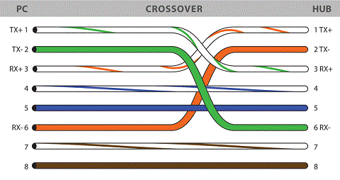 (http://www.fiber-optic-cables-plus.com, n.d.)

* A crossover is different from a straight through in that;
  + Connector 1 – pin 1 must link to connector 2 – pin 3
  + Connector 1 – pin 2 must link to connector 2 – pin 6
  + Connector 1 – pin 3 must link to connector 2 – pin 1
  + Connector 1 – pin 6 must link to connector 2 – pin 2.
  + The rest are the same as a straight through.

Investigate the role of “refractive index” in fibre optics and find out what the rule is for “Total internal reflection”

* Fibre optics cable has 2 innermost layers, called the core and the cladding. These have different refractive indices, with the cladding having a lower refractive index of n2 and the core having the higher refractive index of n1. This helps guide the light through the core of the cable.
* For total internal reflection the light ray must hit the cladding at what is called the critical angle or more. This allows total internal reflection to occur which means the light is reflected back into the glass and not out into the cladding.

What are the channels available in a wireless 802.11n network?

* Depending on where you are in the world will determine which channels are available for you to use. I am only going to highlight the channels in use in Europe.
  + At 2.4 GHz band there are 13 channels available. Channels 1 – 13.
  + At 5 GHz band there are 19 channels available. Channels 36, 40, 44, 48, 52, 56, 60, 64, 100, 104, 108, 112, 116, 120, 124, 128, 132, 136 and 140.

What is the transmission media used for Bluetooth? What frequencies are used and what data rates are possible?

* Wireless is the transmission media used for Bluetooth.
* Bluetooth uses frequencies 2.4 to 2.485 GHz, with the latest version of Bluetooth a data rate of 24 Mbit/s is possible.

**Week 3**

**Research**

Compare communication methods - TCP/UDP

* Both are protocols which are used for sending packets of data. They both work in the transport layer with the internet protocol.
* TCP is a connection-oriented protocol where as UDP is connectionless protocol.
* TCP has error correction, recovery options and makes sure all the packets are delivered.
* UDP sends the packets but doesn’t make sure the packets are received or if there are in the correct order.
* An example of TCP would be when you are browsing the internet and an example of UDP would be a live video stream.

How does QoS relate to VoIP?

* QoS directly affects VoIP, by setting up a router to prioritising the VoIP data sent and received. This helps to reduce or stop choppy/stuttering voice communication due to other applications using up available bandwidth.

List the layers of the OSI model

There are 7 layers of the OSI model;

* Physical (Layer 1)
* Data Link (Layer 2)
* Network (Layer 3)
* Transport (Layer 4)
* Session (Layer 5)
* Presentation (Layer 6)
* Application (Layer 7)

**Tutorial**

What is meant by the term network topology?

* The name given to differentiate between the different arrangement of nodes and connecting lines within a network is a Topology. Some examples of these are Bus, Star, Token Ring, Mesh and Tree.

List 2 factors that would need to be considered when choosing any particular network topology.

* You would have to consider cost and security before choosing a particular network topology to install.

Sketch a diagram for each of the following topologies and list 2 advantages and 2 disadvantages for each of these:

Bus

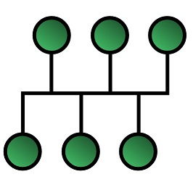 (wikipedia, n.d.)

Advantages

* Cheap to install.
* Easy to install.

Disadvantages

* If the main cable get damaged anywhere it will cause the network to fail. This makes it hard to find the fault in the network.
* There is no security between workstations on the network.

Star

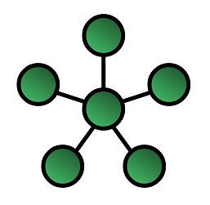 (wikipedia, n.d.)

Advantages

* It is easy find faults, if a cable in the network gets damaged it will only effect the individual node.
* Easy to install.

Disadvantages

* It is expensive to install as there is more cable and extra hardware needed.
* If the network switch fails then all nodes connected to the switch will not be able to access the network.

Ring

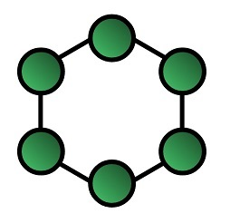 (wikipedia, n.d.)

Advantages

* Good performance because the data traffic flows in the one direction so there is less chance of a collision.
* Adding new nodes has little impact on the performance of the network.

Disadvantages

* If the network cable get damaged anywhere it will cause the network to fail. This makes it hard to find the fault in the network.
* To add a new node, you must temporarily shut the network down.

Mesh

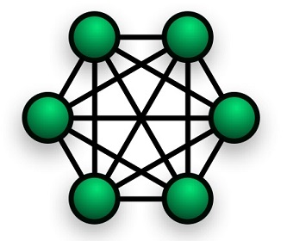 (wikipedia, n.d.)

Advantages

* It is reliable because if there is a damaged cable it won’t affect the performance of the network.
* The network can be expanded without any negative affect on the existing nodes.

Disadvantages

* The cost is high for this network.
* Maintenance of the network is complicated and difficult.

What is the meaning of the term “Hybrid Topology”?

* Hybrid topology is when you connect 2 or more different types of network topologies together.

What are the 4 characteristics of any network?

* Cost
* Security
* Scalability
* Speed

Which of the characteristics refers to the ease of expansion?

* Scalability refers to the ease of expansion, the ability to include new network hardware and users.

Which of the network topologies are fault tolerant to one computer going down?

* Star and Mesh topologies are able to continue in operation when only one computer goes down.

When is Security an issue with computer topologies?

* Security is an issue when the data does not go directly to intended destination. Topologies like Bus are poor for security because the data is available for any node connected to the network to access.

What is QoS as related to computer networks?

* QoS is a networks ability to prioritise selected network traffic, it does this with various hardware and settings used manage the networks resources. This helps to improve the overall quality of service to the applications whose network traffic has been selected.

When is QoS used in computer networks?

* QoS when using an inelastic service like VoIP or streaming media content. The reason for this is that you don’t want a VoIP conversation to be choppy or for your streamed content to stutter.

What is UDP?

* User Datagram Protocol (UDP) is a connectionless protocol that runs in the transport layer on top of the Internet protocol. It is used for sending data packets over the IP quickly. UDP is used for sending data like live streams.

What is TCP/IP?

* Transmission Control Protocol (TCP)/ Internet Protocol (IP) is a connection-based protocol that also like UDP runs in the transport layer on top of the Internet protocol. It is used for sending data packets over the IP reliably. TCP is used for browsing the internet and sending/receiving emails.

Explain why TCP/IP is more reliable than UDP for communication

* TCP/IP is more reliable than UDP for communication because TCP/IP has error correction, recovery options and will send the data packets in the correct order.
* The recipient of the data packages will send back messages to the sender saying it has received the data packets, If any errors are found TCP/IP will resend the data packets.
* The data packets are tracked, this helps to eliminate lost or corrupted data in transit.

**Activity**

Find out which topology is the most popular and why.

It depends on the size of the network.

For a WAN like the internet a Mesh topology is the most popular.

* A Mesh network is considered very reliable and has good security.
* If there is problem in connection between two nodes, the issue is isolated and doesn’t affect the network as a whole.

For a LAN in an office the Star topology is the most popular.

* It is popular because it is easy to install and easy to find faults on. If a cable on the network gets damaged it will only affect the individual node.
* The use of a Switch or router as a central devices helps in monitoring the network.
* It allows for easy expansion of the network.

Investigate what steps can be taken in general to make a computer network more fault tolerant.

* The first step would be to use a network which inherently was more fault tolerant like a Star or Mesh topology. If you are using another topology, then using current equipment that is in good condition would be key to making the network more fault tolerant.

Find out what types of communication uses UDP protocol.

* UDP is used for video and voice communication.

**Week 4**

**Tutorial**

Give 3 reasons why is the OSI model needed in the field of computer networking?

* It makes the communication process easier to learn by breaking it down into smaller pieces.
* It standardises interfaces across the industry. Allows for different vendors to develop and support these interfaces.
* It reduces the complexity. This allows for faster and easier component development and design.

Which standards organisation published the OSI model in 1983?

* The International Organisation for Standardisation (ISO)

How many layers are in the OSI model?

* There are 7 layers to the OSI model.
  + Application
  + Presentation
  + Session
  + Transport
  + Network
  + Data Link
  + Physical

For each layer of the OSI model state the layer name and 2 tasks associated with each layer.

Application

* Network Processes (Such as email, web browsing).
* User authentication.

Presentation

* Formats and encrypts data to be sent out.
* This is where the data is transformed into a form which the application layer can use.

Session

* Allows for establishing, maintaining and terminating connections.
* Enables the applications to communicate over the network by using a standardised set of services.

Transport

* Ensures data is transferred from one to another.
* Provides flow control of the rate of data transmission.

Network

* Routing.
* Logical Addressing.

Data Link

* Data Framing, the encapsulation of network layer data packets into frames.
* Logical Link Control (LLC) allows for the establishment and control of logical links between local devices on a network.

Physical

* Data transmission and reception (bit by bit delivery).
* Encoding and signalling.

Which layer is responsible for the transmission of the data bits from the sender to the receiver?

* Layer 1 Physical.

Which layer is responsible for fault detection and recovery?

* Layer 4 Transport.

Which layer is responsible for routing of the data?

* Layer 3 Network.

Which layer is responsible for dealing with IP addresses?

* Layer 3 Network.

Which layer is responsible for dealing with MAC addresses?

* Layer 2 Data Link.

**Week 5**

**Tutorial**

Give 3 reasons why is the OSI model needed in the field of computer networking?

* It makes the communication process easier to learn by breaking it down into smaller pieces.
* It standardises interfaces across the industry. Allows for different vendors to develop and support these interfaces.
* It reduces the complexity. This allows for faster and easier component development and design.

Which standards organisation published the OSI model in 1983?

* The International Organisation for Standardisation (ISO)

How many layers are in the OSI model?

* There are 7 layers to the OSI model.
  + Application
  + Presentation
  + Session
  + Transport
  + Network
  + Data Link
  + Physical

For each layer of the OSI model state the layer name and 2 tasks associated with each layer.

Application

* Network Processes (Such as email, web browsing).
* User authentication.

Presentation

* Formats and encrypts data to be sent out.
* This is where the data is transformed into a form which the application layer can use.

Session

* Allows for establishing, maintaining and terminating connections.
* Enables the applications to communicate over the network by using a standardised set of services.

Transport

* Ensures data is transferred from one to another.
* Provides flow control of the rate of data transmission.

Network

* Routing.
* Logical Addressing.

Data Link

* Data Framing, the encapsulation of network layer data packets into frames.
* Logical Link Control (LLC) allows for the establishment and control of logical links between local devices on a network.

Physical

* Data transmission and reception (bit by bit delivery).
* Encoding and signalling.

Which layer is responsible for the transmission of the data bits from the sender to the receiver?

* Layer 1 Physical.

Which layer is responsible for fault detection and recovery?

* Layer 4 Transport.

Which layer is responsible for routing of the data?

* Layer 3 Network.

Which layer is responsible for dealing with IP addresses?

* Layer 3 Network.

Which layer is responsible for dealing with MAC addresses?

* Layer 2 Data Link.

Which layer information is used by a Router?

* Layer 3 Network.

Which layer information is used by a Switch?

* Layer 2 Data Link.

Which layer is used by a Hub?

* Layer 1 Physical.

Which layer does the TCP protocol operate at?

* Layer 4 Transport

Which layer does the IP protocol operate at?

* Layer 3 Network.

What is a PDU?

* Packet Data Unit or Protocol Data Unit.

What is meant by data encapsulation?

* It is where outgoing data is packaged and identified for delivery to the layer underneath.

What is the PDU at the Transport layer?

* Segment.

What is the PDU at the Network layer?

* Packet.

How many layers are in the TCP/IP protocol model?

* 4 Layers.

Show with a diagram how the OSI and TCP/IP models compare

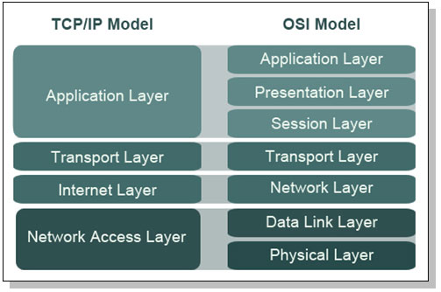 (http://optimus5.com/, n.d.)

At what level of the OSI model does the HTTP protocol work?

* Application (Layer 7)

At what level of the TCP/IP model does the UDP protocol work?

* Transport (Layer 3)

When the PDU is a packet state what the corresponding layers are for the OSI and the TCP/IP models

* OSI Model – Network (Layer 3) corresponds with TCP/IP Model – Internet (Layer 2)

When data formatting is considered state what the corresponding layers are for the OSI and the TCP/IP models

* OSI Model – Presentation (Layer 6) corresponds with TCP/IP Model – Application (Layer 4)

**Activity 1**

Which layer information is used by a Router?

* Internet (Layer 2)

Which layer information is used by a Switch?

* Network Access (Layer 1)

Which layer is used by a Hub?

* Network Access (Layer 1)

Which layer does the TCP protocol operate at?

* Transport (Layer 3)

Which layer does the IP protocol operate at?

* Internet (Layer 2)

What is a PDU?

* Packet Data Unit or Protocol Data Unit. It is the units of data passed between layers.

What is meant by data encapsulation?

* It is where outgoing data is packaged and identified for delivery to the layer underneath.

What is the PDU at the Transport layer?

* Segment.

What is the PDU at the Network layer?

* Packet.

How many layers are in the TCP/IP protocol model?

* 4 Layers.

Show with a diagram how the OSI and TCP/IP models compare

 (http://optimus5.com/, n.d.)

At what level of the OSI model does the HTTP protocol work?

* Application (Layer 7)

At what level of the TCP/IP model does the UDP protocol work?

* Transport (Layer 3)

When the PDU is a packet, state what the corresponding layers are for the OSI and the TCP/IP models

* OSI Model – Network (Layer 3) corresponds with TCP/IP Model – Internet (Layer 2)

When data formatting is considered, state what the corresponding layers are for the OSI and the TCP/IP models

* OSI Model – Presentation (Layer 6) corresponds with TCP/IP Model – Application (Layer 4)

**Activity 2**

Find out what the general structure of a typical data packet is in the OSI model

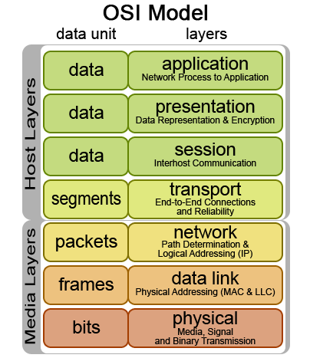 (home.earthlink.net, n.d.)

Which model was developed first between the OSI and the TCP/IP?

* TCP/IP was developed before the OSI Model.

Regarding the OSI model sketch a diagram of how the data changes as it travels from the Application layer of the Sender to the Application layer of the Receiver.

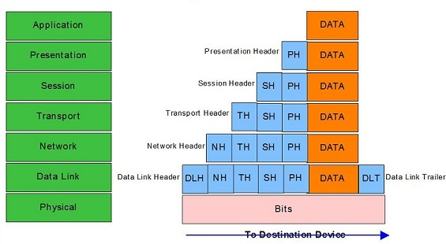 (http://www.routemybrain.com/, n.d.)

Find out what DNS and ARP are and what their purpose is in computer networking

* DNS is Domain Name System. It is a protocol which translates domain names into IP addresses.
* ARP is Address Resolution Protocol. It is a protocol which maps IP network addresses to the hardware addresses used by a data link protocol.

**Week 6**

**Tutorial**

What is the meaning of the term “hop” with regards to routing?

* A “hop” is when data moves from one node to another, it is one portion of the path.

What does a routing table tell the router?

* A routing table stores information about networks and tells the router how they can be reached.

At what OSI level does routing and IP addressing happen?

* Network (Layer 3)

Convert 143 to binary

* 10001111

Convert 10110011 to decimal

* 179

Sketch a simple diagram which illustrates the concepts of Unicast, Broadcast and Multicast communication

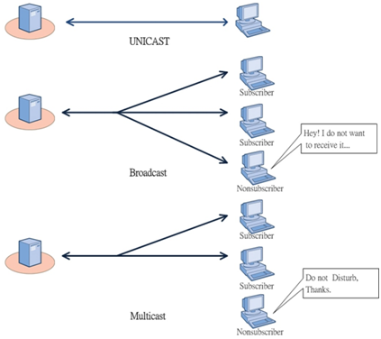 (http://www.onurcanalp.com/, n.d.)

How many bits are involved with IPv4 and how many addresses are available?

* 32 bits.

The IPv4 address is split into two fields, what are their names?

* Network and Host.

What is the task of a subnet mask?

* It divides the IP address into network address and host address.

State the ranges involved for network and host for each of the classes A, B, C, D, E

* A (0 – 126)
* B (128 - 191)
* C (192 - 223)
* D (224 - 239)
* E (240 - 255)

Why is the available addresses reduced by 2 for each subnet?

* It is to allow one for the Network ID and one for the Broadcast ID.

How many bits are used for addressing in the IPv6?

* 128 bits.

Write the IPv6 address FE12:0012:05FD:35DD:0000:0000:0000:0012 out in reduced form

* Omit leading zeroes: FE12:12:5FD:35DD:0:0:0:12
* Compress groups of zero: FE12:12:5FD:35DD::12

State the class A, B and C ranges of private addresses

* A – 0.0.0.0 – 127.255.255.255
* B – 128.0.0.0 – 191.255.255.255
* C – 192.0.0.0 – 223.255.255.255

What is CIDR and why is it used?

* CIDR is Classless Inter-Domain Routing. It allows for more efficient allocation of IP addresses. This allowed the number of available IP address to increase. CIDR addresses reduced the size of routing tables.

State the subnet mask for /24 as in CIDR notation

* 255.255.255.0

How many ports are available in a host?

• 65536

What range of port numbers is categorised as well known?

* 0 – 1023

What range of ports is categorised a dynamic and private?

* 49152 - 65535

State the port numbers which are in use for (a) http (b) FTP (c) https (d) DNS

* 80
* 20 (data) 21 (control)
* 443
* 53

**Activity**

What are the private addresses used for?

* These are used for nodes which don’t connect directly to the internet. An example would be a computer on an Intranet.

What are the Broadcast and Multicast communication modes used for?

* Broadcast
  + The Address Resolution Protocol (ARP)
  + The Dynamic Host Configuration Protocol (DHCP)
* Multicast
  + Streaming multimedia

When did CIDR notation come into use?

* It was introduced in 1993 by the Internet Engineering Task Force.

**Week 7**

**Tutorial**

State 2 major characteristics about WANs that does not apply to LANs

* It operates over a broader geographical area
* It uses the services of Carriers for examples ISP’s and Telephone companies.

What is the main task of a WAN?

* To connect LAN’s together.

At what OSI levels does a WAN operate?

* OSI Level 1 (physical) and Level 2 (data link)

State 3 leased line options for connection to a WAN

* T1, T3, E1 and E3.

State 2 circuit switched and 2 packet switched technologies associated with WANs

* Circuit Switched
  + Analogue Dial-UP
  + ISDN
* Packet Switched
  + X.21
  + X.25
  + Frame Relay

State 2 authorities that establish WAN specifications

* ISO – International Standards Organisation
* EIA – Electronic Industries Alliance

With the aid of a sketch, explain the meaning of the terms DTE and DCE with regards to WANs

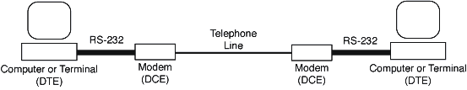 (bioweb.biology, n.d.)

What is a CSU/DSU as used in WANs and when is this device used?

* CSU/DSU (Channel Service Unit/Data Service Unit) are usually contained in one piece of hardware which connects a terminal to a digital line. It is used to convert incoming and outgoing digital signals, to allow your network to work with a digital line.

What does HSSI mean in relation to WANs?

* High Speed Serial Interface (HSSI) is a communications interface used between devices which are within 15m or less. It connects a LAN router to a higher speed digital line of a WAN.

What is the maximum speed of an EIA/TIA – 612/613 interface?

* 52Mbps.

With regards to telephone terminology, explain the meaning of the following terms:

* Local Loop
  + It is the connection from the central office in the area to the home.
* Demarcation Point
  + It is the physical point where the phone companies’ network ends and the private network of the home begins. It also signifies the change in responsibility for the installation and maintenance of the wires.
* CO
  + Central office is the point where the local loop terminates and connects to a larger switching system.
* CPE
  + Customer premises equipment are hardware devices, found on the customers premises. Examples of these would be telephone handsets, routers and cable tv set top boxes

What is ISDN and what is its highest speed with regards to WANs?

Integrated services digital network (ISDN) is a set of standards used to send data over the public switched telephone network. Up to 128 Kbps is the highest speed with regards to WANs.

State 2 advantages of having a leased line for a WAN connection

* You have a dedicated line which provides a full time service.
* You lease the line; therefore you get a guaranteed bandwidth for all communications.

What are the highest speeds for a leased line in USA and in Europe?

* USA - 44.736Mbps
* Europe - 34.368Mbps

**Activity**

Find out more about the dial-up connection technology:

* What is the BW required to transmit human speech?
* 4 KHz
* What different types of Modem are available?
  + Soft modems
  + Controller based modems
  + External Modems
* What is the best BW of a bare local loop. (Bare meaning no additional parts to limit the BW)
  + The best bandwidth of a bare local loop is 4000Hz. The length and quality of the copper wires have an effect.

Find out more details regarding ISDN BRI and PRI connections:

* What is a Bearer channel and how many are there?
* Bearer channel is a ISDN channel and there are 30 of them in Europe
* What is a Delta channel and what is its purpose?
* Delta channel is an ISDN signalling channel. This channel carries signalling and control information.
* What is TDM and how does it work?

Time-division multiplexing, it is where 2 or more channels of information can be transmitted at once.

Find out two companies in the UK where we can lease a high speed data line and at what cost?

BT Infinity – 76Mb - £47.99

Virgin Broadband – 200Mb - £46.99

**Week 8**

**Tutorial**

Give 3 reasons why packet switching is preferred to circuit switching

* It is more efficient with its use of bandwidth.
* It only uses resources as and when it needs to.
* It can handle messages of different sizes easily.

Name 4 packet switched technologies

* X.25
* Frame Relay
* PVNs
* Wireless

Why does X.25 technology feature extensive error checking?

* Because of the unreliable nature of the infrastructure.

What is the maximum speed quoted for X.25?

* Up to 64kbps.

Which packet switching technology is an advancement of the X.25 technology?

* Frame Relay.

What are the data packets called within frame relay technology?

* Frames.

What is the maximum speed quoted for frame relay?

* 1.544Mbps

What protocol is used by frame relay to achieve the routing?

* Data Link Connection Identifier

What is ATM?

* Asynchronous Transfer Mode is high-speed networking standard which is able to support both voice and data communications.

What is different about the cells in the ATM technology as compared with the data structures in X.25 and frame relay technologies?

* ATM used fixed sized cells which are 53 bytes whereas X.25 and frame relay use variable size packets or frames.

What speeds are quoted for ATM technology?

* Upto 622Mbps.

What is ADSL?

* Asymmetrical Digital Subscriber Line, it is asymmetrical because it uses the majority of the bandwidth for download and a small amount of the bandwidth for upload.

What is SDSL?

* Symmetrical Digital Subscriber Line, it is symmetrical because it supports the same download and upload speed.

What is meant by the xDSL being a distance sensitive technology?

* Its means that the speed and signal quality decreases as the distance to the central office increases.

What is meant by ADSL being asymmetrical?

* It is asymmetrical because it uses the majority of the bandwidth for download and a small amount of the bandwidth for upload.

State the speed and the distances involved with ADSL and SDSL

* ADSL – 1,544 to 8,448 Mbps download and 640 to 1,544 upload at a distance of between 100 to 5000m.
* SDSL – 1,544 Mbps or 2,048Mbps (1 pair) both download and upload at a distance of between 100-7000m.

What job does the low pass filter perform in an ADSL installation?

* An ADSL filter sends the correct band of frequencies to the appropriate sockets, whether that is for your telephone or ADSL.

State the typical download/upload speeds for a cable modem

* 30 Mbps for download and 3 Mbps for upload, although these speeds are forever increasing.

State 3 reasons for the need of a VPN

* It allows you to send encrypted sensitive data over the public internet.
* Its technology allows for organisations to create private networks over the internet which increases the security and maintains confidentiality.
* It allows employers to provide access to their intranet to their employees who telecommute.

What is the name given to the data path in a VPN?

* The data path is called a tunnel.

State one protocol that is used with VPNs

* PPTP (Point to Point Tunnelling Protocol)

How does wireless technology achieve a blanket coverage of a wireless signal?

* By using the wireless local area network standard IEEE 802.11 over a 5GHz and 2.4GHz spectrum band.

What is MPLS?

* Multiprotocol Label Switching is a routing protocol which works over both layer 2 (data link) and layer 3 (network) of the OSI model.

What is HDLC?

* High Level Data Link Control is a transmission protocol which organises data into frames which allows for error-free transmission. HDLC controls the speed at which the data is transmitted.